 |  | Technical Data Sheet
www.versalis.eni.com |  |  | info.polyethylene@versalis.eni.com
RIBLENE ® |  |  | MV 10 R
LDPE |  |  | Low density polyethylene
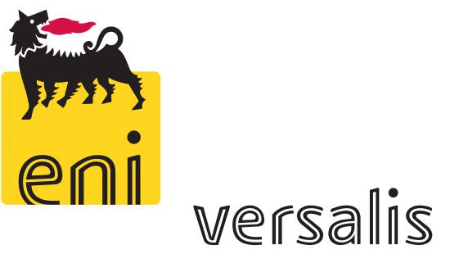
Riblene MV 10 R is a low density polyethylene resin having an excellent fluidity (LDPE).

Parts made by Riblene MV 10 R are highly flexible.

Main Application

Riblene MV 10 R is ideal for injection moulding applications. Riblene MV 10 R is recommended for low thickness and very complex articles requiring a short production cycle and for basterbatches.

Main Properties

Resin Properties | Value | Unit | Test Method
Melt Flow Rate (190 °C/2.16 kg) | 65 | g/10min | ISO 1133
Melt Flow Rate (190 °C/5 kg) | - | g/10min | ISO 1133
Melt Flow Rate (190 °C/21.6 kg) | - | g/10min | ISO 1133
Density | 0.917 | g/cm3 | ISO 1183
Melting point | 104 | °C | Metodo interno
Brittleness temperature | < 0 | °C | ASTM D 746
Vicat softening point (1 kg) | 82 | °C | ISO 306/A

Mechanical Properties * | Value | Unit | Test Method
Tensile stress at yield | 9 | MPa | ISO 527
Tensile stress at break | - | MPa | ISO 527
Tensile strain at yieal | - | % | ISO 527
Elongation at brek | - | % | ISO 527
Flexural modulus | 110 | MPa | ISO 178
Hardness Shore D | 43 | - | ISO 868 A
Falling Weight: | - | J/mm | ISO 6603-2
Izod impact strength, notched | - | J/m | ISO 180/A
Environmental Stress Cracking Resistance (ESCR) | - | h | ASTM 1693/B

- Values are referred to injection moulded specimens. Actual properties are typical and may vary depending upon operating conditions. R= Made in Ferrara (Italy)

Riblene ® is a registered trademark of versalis

This document is constituted of 2 pages Pag 1/2 November 2014

Processing notes

Processing conditions are depending on several parameters: the shape of the part to be manufactured, the localisation of the injection point, the injection moulding machine and the cooling of the mould. Typical processing conditions:
Temperature profile of the barrel (°C) 160 - 200
Temperature of the mould | (°C) 10 - 30

Storage and Handling

Riblene MV 10 R is supplied in pellet form. This material may readily be conveyed and bulk fed through equipment designed for conventional pelletised polyethylene resin, provided the equipment is designed to prevent accumulation of the fines and dust particles that are contained in all polyethylene resins. These fines and dust particles can, under certain conditions, pose an explosion hazard. We recommend that the conveying system used be equipped with filters of adequate size, operated and maintained in such a manner to ensure that no leaks develop and earthed adequately. We further recommend that good housekeeping should be practised throughout your facility.

The product should be stored in dry conditions at temperatures below 50°C and protected from sunlight. Improper storage can initiate degradation which results in odour generation, colour changes and can have negative effects on the physical properties of the product.
Before using this product it is recommended to read and understand the relevant Safety Data Sheet.

Availability

Contact the versalis sales office nearest to you regarding availability and your specific application requirements.

Food Contact Status

Riblene MV 10 R complies with the rules and regulations of the European Union, as well as other countries, regarding the use of plastic materials in food contact applications. Certificates of compliance are available upon request.

TECHNICAL SERVICE

versalis S.p.A. | Versalis International SA | versalis S.p.A.
Piazza Boldrini, 1 | succursale française | Via Taliercio, 14
20097 S.Donato Milanese, Italia | Port 4531 Route des Dunes - BP | 46100 Mantova, Italia
Tel. +39 02 520.32087 | 59 | Tel. +39 0376 305667
Fax +39 02 520.52052 | F-59279 Mardyck | Fax +39 02 52043

HEADQUARTER

versalis S.p.A.
Piazza Boldrini, 1
20097 S.Donato Milanese, Italia
Tel. +39 02 520.32087
Fax +39 02 520.52052

IMPORTANT: please consult the relevant safety data sheet for more detailed information. The information and data presented herein are to the best of our knowledge true and accurate but no warranty or guarantee, expressed or implied, is made nor is any liability accepted with respect to the use of such information and data.

versalis is available to provide the guaranteed values for each product on demand.

Pag 2/2 November 2014

